

**Changsha University of Science and Technology**

School of Computer and Communications Engineering Experiment Course for Python Programming

# Course Name: Python Programming Grade: 2021 Fall Major: Computer Science and Technology

# Student ID: Gj2021009135 Chinese Name: **莫森**

# Name: Munasinghe Munagamage Don Ashan Dinisuru

# Date: 12/04/2024

1. **The Chinese ID number can be regarded as the unique identification of each person, including our place of birth, date of birth, and gender. The specific rules are, the first and second digits represent the province; the third and fourth digits represent the city; the fifth and sixth digits represent the districts and counties; the seventh to fourteenth digits represent the date of birth; the fifteenth digits And the 16th digit represents the birth order number; the 17th digit represents the gender; the 18th digit is the check code. According to this rule some information can be obtained. This task requires writing a Python program that will obtain the corresponding province according to the input ID number.**

**Example: 430621198208192314**

**43---Hunan province**

**06---Yueyang**

**21---Yueyang County**

**19820819---date of birth**

**23---birth order number**

**1---gender**

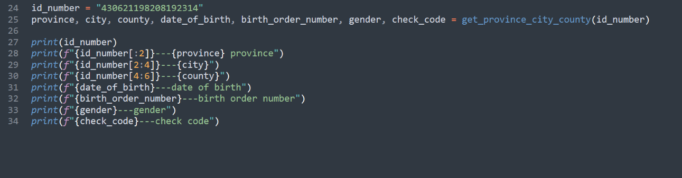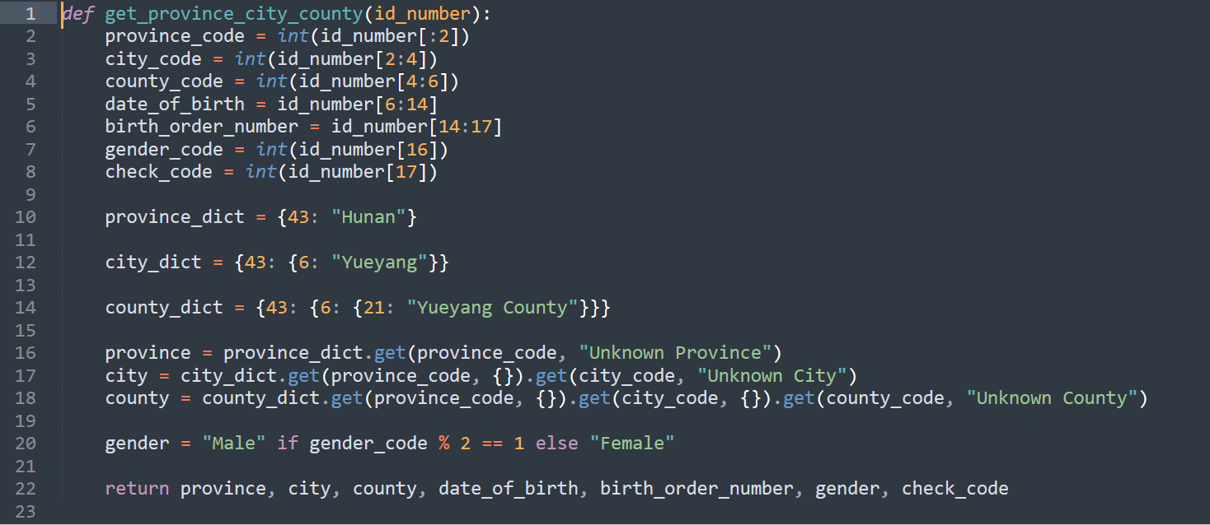**4---check code**

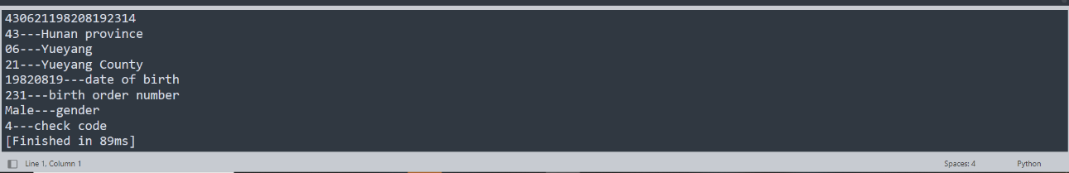

1. **A company receives a lot of couriers every day. In order to distribute the courier to the recipient, it needs to write a Python program that counts all recipient names, phone numbers, and pickup codes into a dictionary, and stores the dictionary in the in a separate file.**

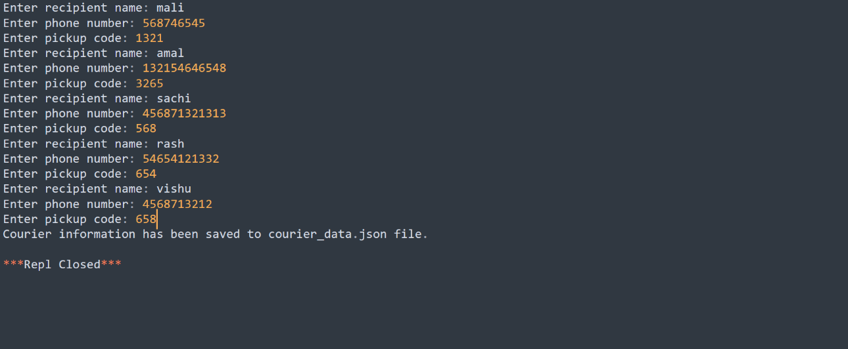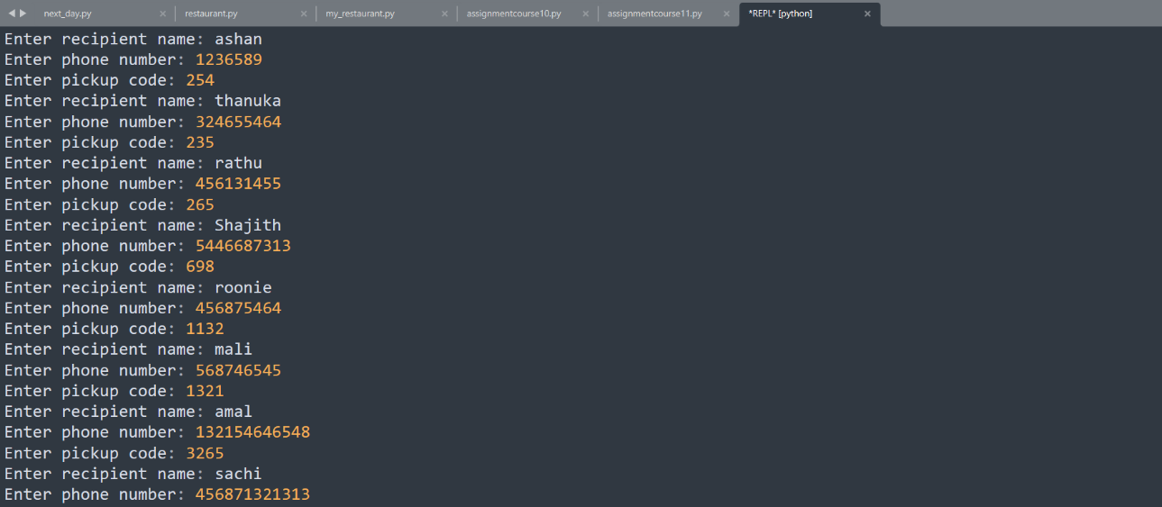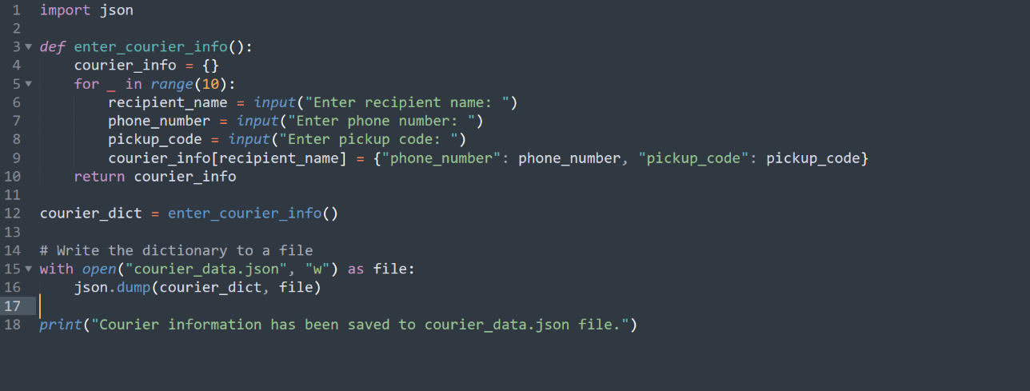**\*\*\* At least 10 items in the dictionary \*\*\***

* **courier_data.json**

{"ashan": {"phone_number": "1236589", "pickup_code": "254"}, "thanuka": {"phone_number": "324655464", "pickup_code": "235"}, "rathu": {"phone_number": "456131455", "pickup_code": "265"}, "Shajith": {"phone_number": "5446687313", "pickup_code": "698"}, "roonie": {"phone_number": "456875464", "pickup_code": "1132"}, "mali": {"phone_number": "568746545", "pickup_code": "1321"}, "amal": {"phone_number": "132154646548", "pickup_code": "3265"}, "sachi": {"phone_number": "456871321313", "pickup_code": "568"}, "rash": {"phone_number": "54654121332", "pickup_code": "654"}, "vishu": {"phone_number": "4568713212", "pickup_code": "658"}}

1. **Given a positive integer, requirements:**

**1). Find how many digits it is**

**2). Print out the digits in reverse order**

**Such as: 198276**

**1 9 8 2 7 6**

**\*\*\*NOTE\*\*\***

* **Do not use the function defined in Python**
* 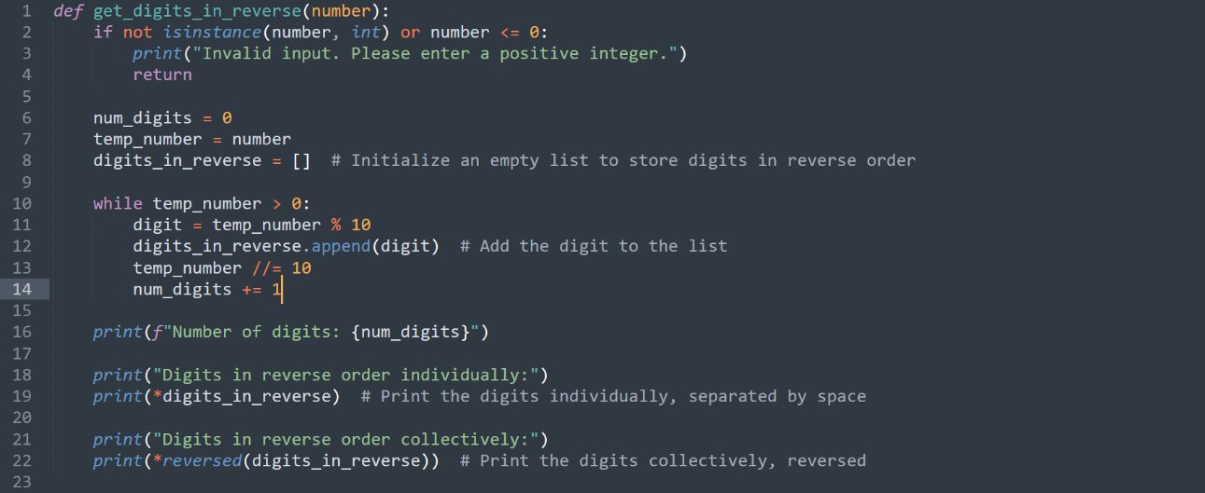**Do not use the function defined in Python. Design an algorithm.**

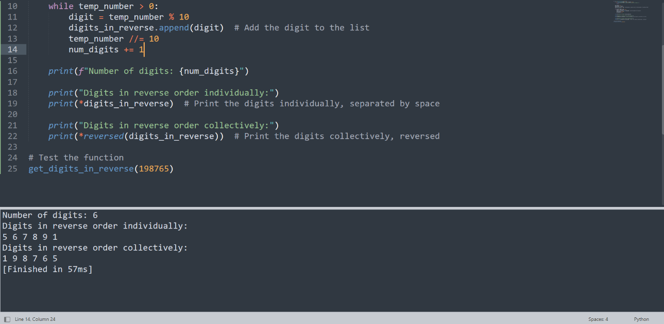

1. **Use Python to crawl Bitcoin's 5-minute transaction data within a day and store it in a CSV file.**

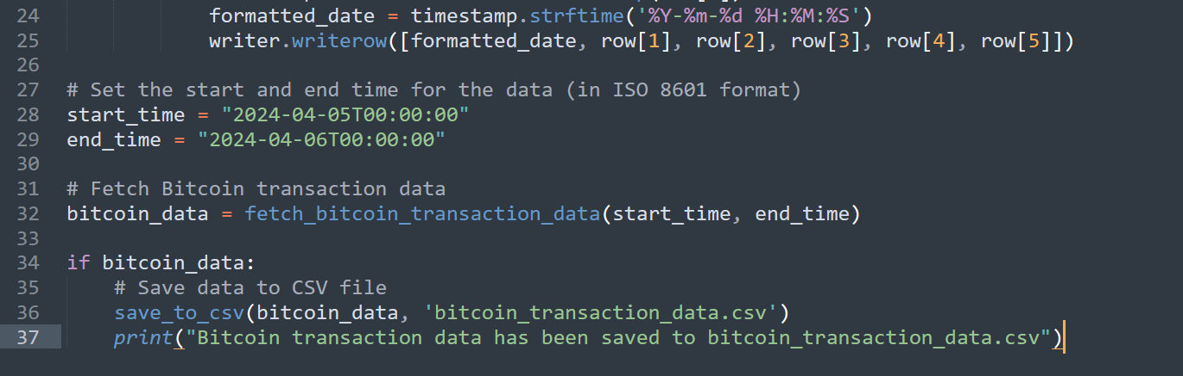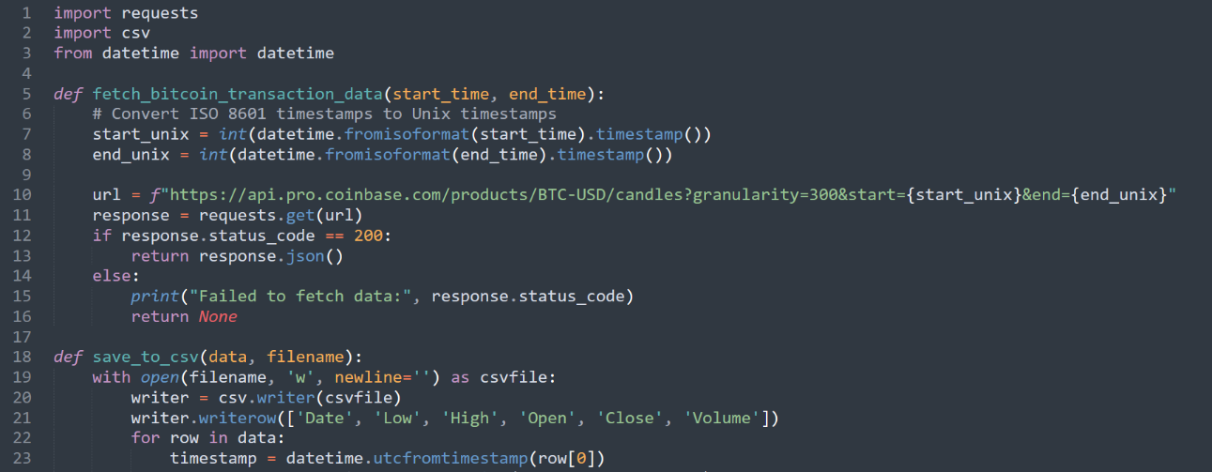**Your source code:**

**Your CSV file:**

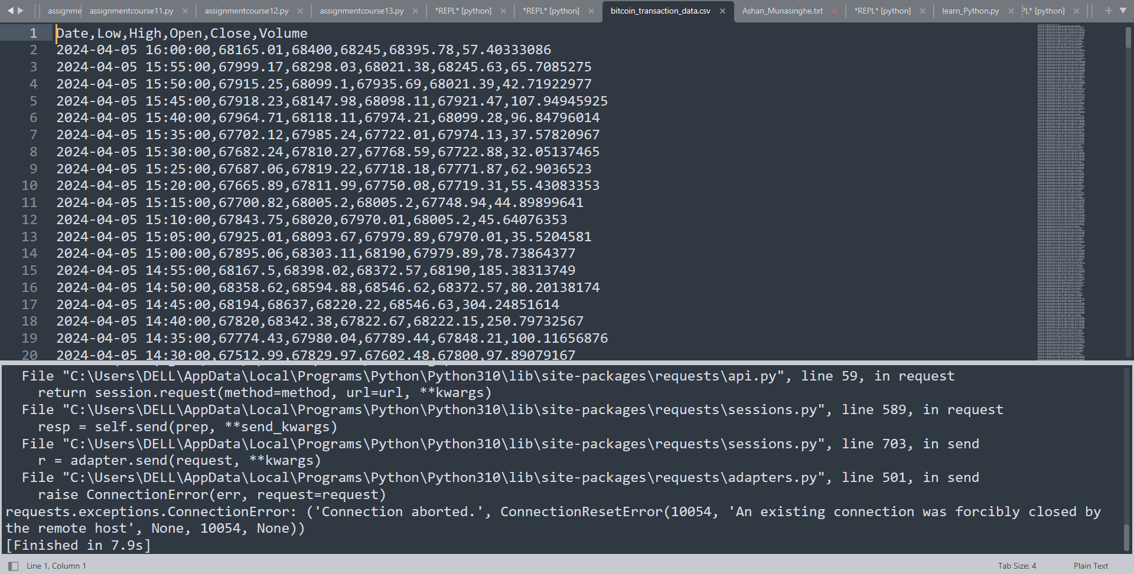

1. **Using python to get the weather information from websites, and display the information on an UI**

**Display:**

**Date:**

**City:**

**Weather: ---snowy, rainy…sunny…**

**Humidity:**

**Tempreture:**

